Paying with a Purchase Order from your school district? Please review the information below to help ensure timely payment of your registration.

- When registering for the conference please list the Purchase Order Number in the appropriate box on the registration form.
- Once you complete the form, click “next” and you will see a screen similar to this:
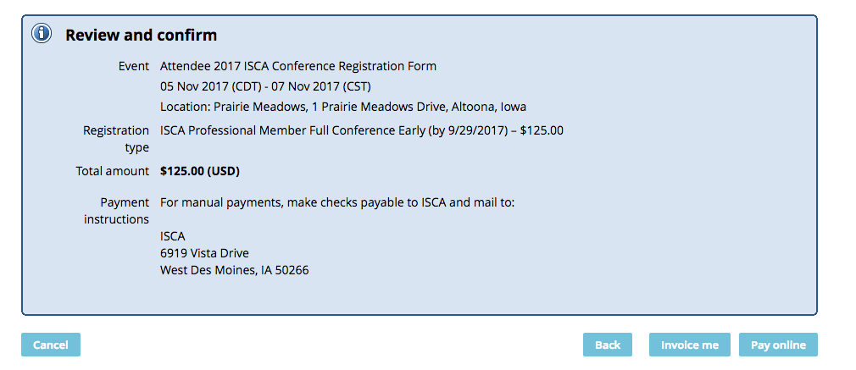
- From this screen select “invoice me”
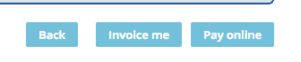
- From that screen select “view/pay invoice”
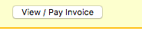
- Print a copy of the invoice and forward this to your business office, accounts payable office, or the person in your district who pays bills.
- You will also receive an invoice as part of your confirmation email. You can also forward this copy to your business office, accounts payable office, or the person in your district who pays bills.
- The most important piece is that the invoice gets forwarded to the person in your district who writes checks and submits payments. Without an invoice that shows them there is a balance due, they will not know to cut a check to ISCA. The Purchase Order is only the tool that approves the expenditure, not the actual payment to ISCA.
- Please make sure that your district has the correct remittance information on record for ISCA. The mailing address, phone number, and fax number changed last year. The correct contact information is:
Iowa School Counselor Association
6919 Vista Drive
West Des Moines, IA 50266
Phone – 515-282-8192
Fax – 515-282-9117

