Embedding Work-Based Learning into ICAP: ISCA 2022 Presentation Links

Presentation Component | Description | Link(s)/QR Code
Presentation Powerpoint | Full powerpoint of presentation with embedded links and direct contact information | Link to Powerpoint
Tools and Resources for ICAP Implementation:

 | Student Interest Inventory: Provides options for use to capture student interest including WBL interest.  Form is provided as a google form for copy in two versions:  long version with additional questions to provide information for counselors/districts wanting to collect additional ICAP driven information (4-year plan, review, advisement, postsecondary planning); Short option that does not have the additional postsecondary and ICAP driven questions.  -Both include a WBL question | Counselors are welcome to modify, copy or adapt the questions and format to best suit student/counselor/district needs  Postsecondary Interest Inventory (Google Form): Short Version  https://bit.ly/3epkEdj  Long Version (Google Form): https://bit.ly/3epkEdj  Longer as DOCX: https://bit.ly/3CvTdGD  Both include identification of WBL interests as a question
 | Focus on the 5 Essential Components: Additional Resources including direct links to WBL tools and information | ISCA Resource Examples  https://bit.ly/3RZZZKg  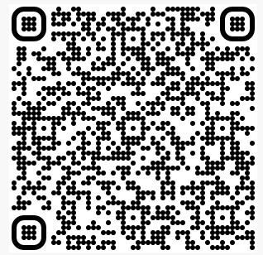
 | Reflection Options:  This document provides a general list of reflection suggestions for use in the ICAP process.  For each of the 5 Essential Components, student reflection is needed- this includes WBL | Reflection options: Document Link  https://bit.ly/3DwCAwb  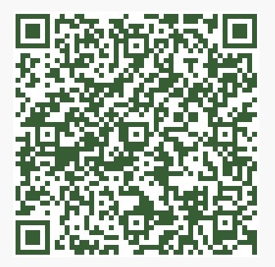
 | Specific WBL Reflection Example:  Counselors should modify this tool to best suit the WBL experience, students and desired data/reflection outcome for their district. It is recommended that no more than 3-5 questions are used at one time. | Please make copy: LINK (Google Form version)  https://bit.ly/3yCBdZY  LINK (Word Format)  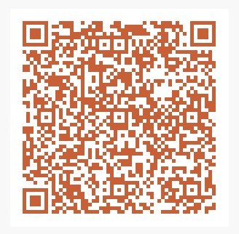
 | WBL Data Collection Tool:  This form could be used to track WBL opportunities in the district.  The vision for this tool is that it can be sent to teachers- especially CTE teachers from whomever in the district does the ICAP data collection  and each WBL experience that occurs can be easily entered  and submitted to a single google sheet for easy tracking  and reporting. | Please make a copy: LINK (Google Form)  https://bit.ly/3rQAVeg
 | Embedding Work-Based Learning Planning Worksheet  Planning worksheet for district use to consider where WBL opportunities currently are present and where additional experiences can be embedded to connect for all students. | Planning Worksheet Link
Updated District Career and Action Plan Template (DCAP) | Updated DCAP planning template:  This updated template provides districts with additional information th strengthen their ICAP implementation and includes WBL and FAFSA advisement sections based upon 2022 legislative updates to ICAP requirements | Forced Copy can be made from: bit.ly/3EgBPbw  (Google Doc)  Template can be found on Career and Academic Planning site: LINK (word version)

